City of Nanaimo

REPORT TO COUNCIL

DATE OF MEETING: 2013-OCT-7

AUTHORED BY: DAVE STEWART, PLANNER
PLANNING & DESIGN SECTION

RE: DEVELOPMENT VARIANCE PERMIT NO. DVP217 - 680 TRANS CANADA HIGHWAY

STAFF RECOMMENDATION:

That Council issue Development Variance Permit No. DVP217 at 680 TRANS CANADA HIGHWAY.

PURPOSE:

The purpose of this report is to seek Council authorization to vary the provisions of sign type, area and height within the City of Nanaimo “SIGN BYLAW 1987 NO. 2850" in order to permit two LED signs at the Departure Bay Ferry Terminal.

BACKGROUND:
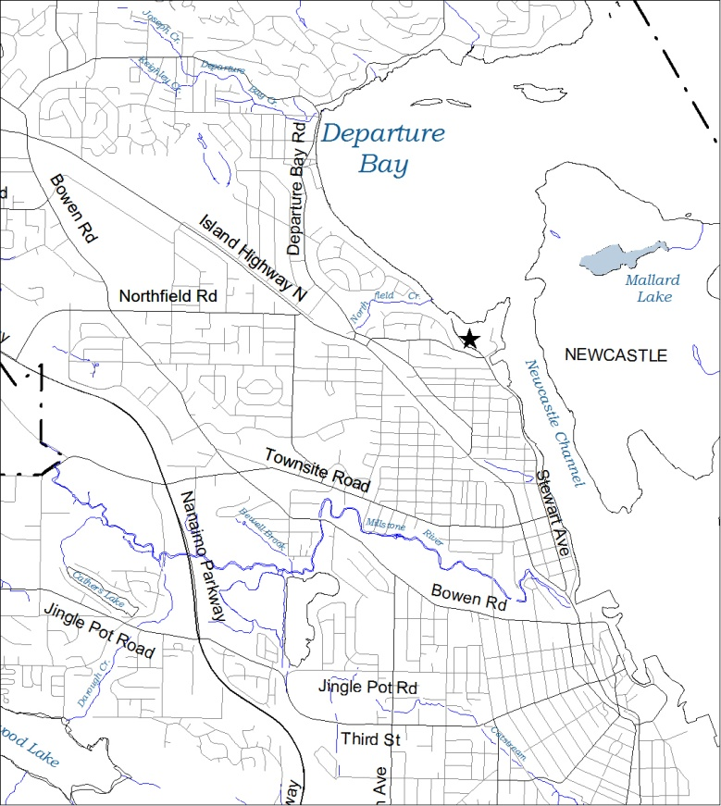
A Development Variance Permit (DVP) application was received from Mr. Sylvain Boulanger (Boldwing Continuum Architects Inc.), on behalf of the BC Transportation Financing Authority, to vary the provisions of the City of Nanaimo “SIGN BYLAW 1987 NO. 2850" in order to permit two LED animated signs.
Map 1- General City Location

On 2011-OCT-3, Council approved a similar DVP application in order to permit a similar LED sign at the Duke Point ferry terminal.

At the Council Meeting held 2013-SEP-23, Council approved Statutory Notification for Development Variance Permit DVP00217. Statutory Notification must take place prior to Council’s consideration for the approval of the variance.

Subject Property

The subject property is the BC Ferry Departure Bay terminal located at 680 Trans Canada Highway, north of the Stewart Avenue / Brechin Road intersection. The general location of the property within the City is indicated with a star on ‘Map 1- General City Location’.
Map 2- Subject Property Location

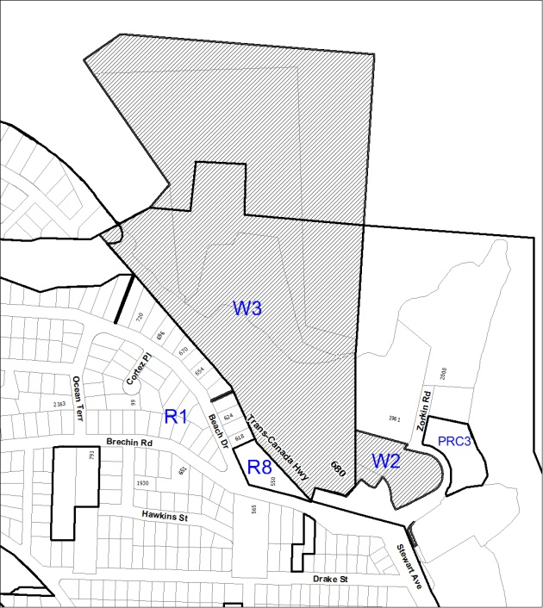
The property is included within the Brechin/ Newcastle Neighbourhood Plan Area. The majority of the subject property is designated as Medium Low Density Waterfront within the plan. A number of single residential dwellings border the property, Beach Drive to the west, and Brechin Road to the south. The lots to the west of the subject property encompass a variety of marine industrial uses and a seaplane terminal. The Stones Marina commercial development and the Brechin Boat Ramp are located to the south.
Map 2- Subject Property Location

The total size of the subject property is
24.6 ha (60.8 acres) including the foreshore area. The distance from the highway entrance to the property and the ferry dock is approximately 500 m. The subject property is included within the Newcastle Waterfront (W3) zone. A map of the subject property location and zoning is shown on
‘Map 2 - Subject Property Location’.

DISCUSSION:

Proposed Development

In order to communicate information to vehicles waiting to board a BC Ferry, the applicant plans to construct two LED signs within the BC ferry boarding area. The applicant intends to install the proposed signage to reduce the usage of the current loudspeaker public address system. One of the proposed signs will be mounted to the car deck used for vehicle loading. The sign will be mounted 6.4 m above the ground, will be 4.1 m in height and 7.3 m wide, with a total sign area of 29.93 m². Sign orientation will be to the east towards Newcastle Channel and the adjacent waterfront industrial lands. An elevation drawing of the proposed sign is shown below as ‘Figure 1- Mounted Sign Elevation’
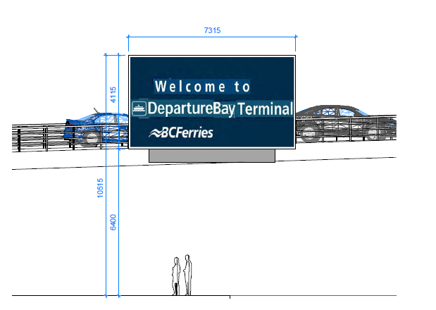
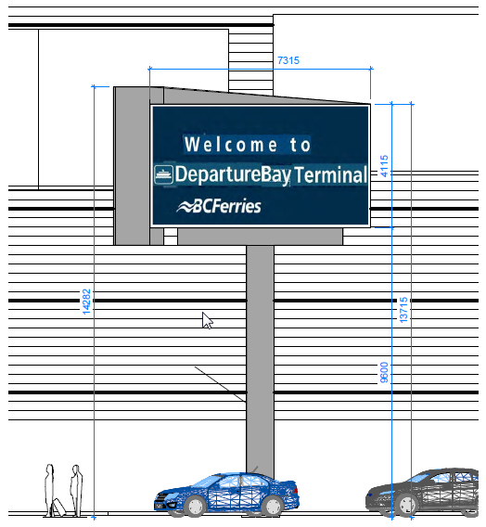
Figure 2- Freestanding Sign Elevation
Figure 1- Mounted Sign Elevation
The second proposed LED sign is free standing (Figure 2) which will be located near the eastern property line in front of the high use vehicle lanes. The sign will be oriented to the southeast toward the vehicle waiting area and Newcastle Channel. The sign will be mounted on a 9.6 m column and will measure 13.7 m to the top of the sign. The total size and dimensions of the free standing sign will be the same as that for the mounted sign (4.1 m x 7.3 m).

A site plan showing the location and orientation of both proposed signs is shown below as ‘Figure 3- Site Plan’.

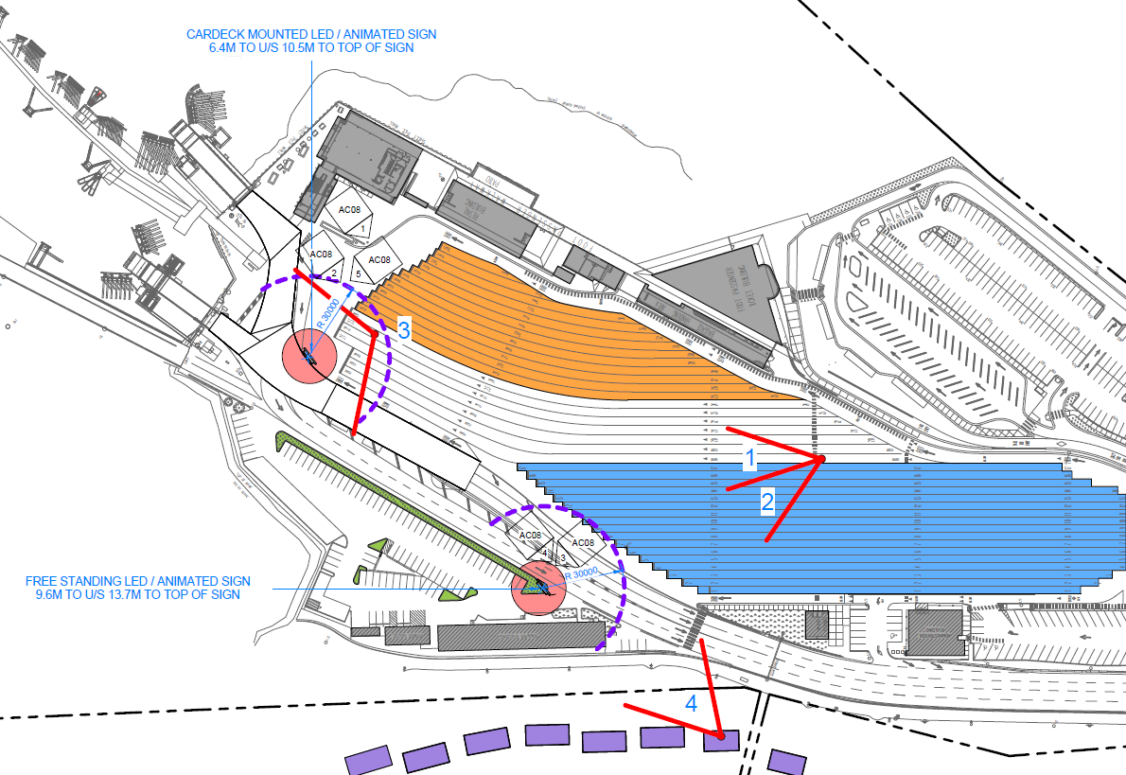
Figure 3- Site Plan

In order to determine that the proposed signs can easily be seen from waiting vehicles, but not from the adjacent single residential dwellings, the applicant has created a number of 3D models indicating the view towards the sign from various locations within the parking area and from the homes on Beach Drive. The first view analysis, show below as Figure 4 and 5, indicates two separate views of both proposed signs from the main vehicle waiting area.

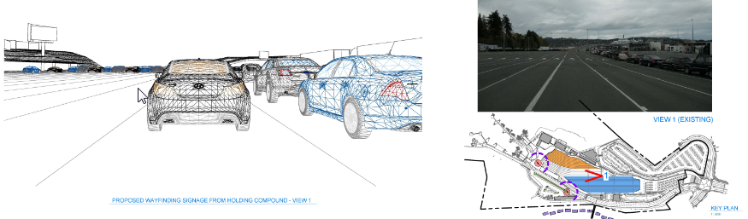
Figure 4- View Analysis Point 1

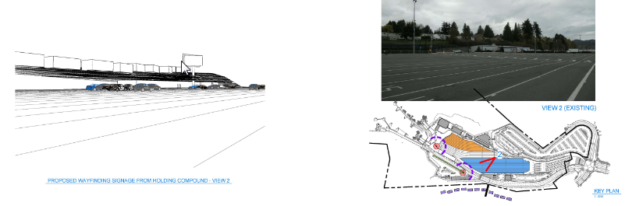
Figure 5- View Analysis Point 2

Figure 6, shows a view of the proposed mounted LED sign from the truck and trailer vehicle waiting area. The view plane is shown as Point 3 on the site plan.

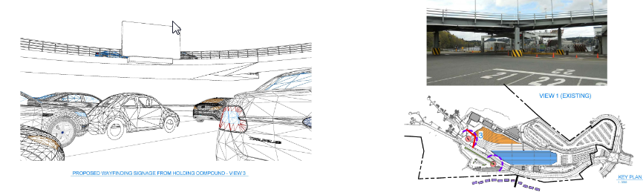
Figure 6- View Analysis Point 3

The final view analysis (Figure 7) was taken from a home on Beach Drive, in order to determine what, if any impact, the proposed LED signage may have on the adjacent residential properties.

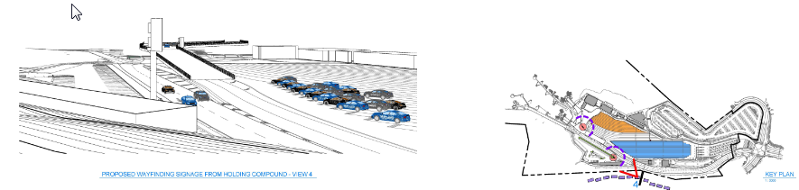
Figure 7- View Analysis Point 4

While the side of the sign will be visible from the neighbouring residences, the LED screen itself will not be, as shown in Figure 7. By orienting the proposed signage towards the vehicle waiting area and ocean, the applicant has worked to prevent potential glare or light pollution issues for the nearby residences.

Neighbourhood Consultation

The applicant has met with the Terminal Liaison Committee (a subset of the Newcastle/Brechin Community Association) which is a group specifically designated to work with BC Ferries to discuss ferry terminal issues, including the proposed signage. Committee members were driven to the Duke Point Ferry terminal in order to view its existing LED signage at terminal. The proposed signs will be approximately the same size as the existing Duke Point signage.

LED Design Guidelines

At its meeting held 2011-FEB-14, Council adopted "Guidelines/Operational Requirements to be
Considered as Part of the Development Variance Permit Application Process" (Attachment A).

The application meets all the relevant Guideline criteria, with the exception of the total sign area and number of signs (Guideline 2). The LED Guidelines recommend no more than one LED sign be permitted per lot and that the maximum LED sign area not exceed 9.29 m². Given the large size of the Departure Bay Ferry terminal, the applicant feels the two proposed 29.93 m² signs are necessary to ensure visibility to all waiting vehicles. The second mounted sign is requested to ensure the signage is visible from the truck and trailer waiting area. The proposed signage represents a deviation from the guideline recommended size and number of signs, and proposes a total sign area of 50.57 m² and one additional sign.

Applicant Rationale

The Applicant Rationale is included as Attachment B.

Required Variances

Section 3 (22) of the City of Nanaimo “SIGN BYLAW 1987 NO. 2850” prohibits “a sign which is animated or includes automated changeable copy except where approved through a development variance permit”. Section 5 (5) (A) (iii) (a) of the Sign Bylaw limits the maximum allowable sign area for a freestanding sign within the Waterfront Zones to 10 m². The maximum allowable height for a free standing sign is 9 m.

A variance is required to permit two automated changeable copy (LED) signs of 29.93 m² each on the subject property. A variance is also required to allow a freestanding sign with a height of 13.7 m.

STAFF COMMENT

The applicants’ intent in installing the proposed LED signage is to present way finding and travel information to vehicle passengers waiting to board a BC ferry. Currently BC Ferries uses a loud speaker system to convey inform information to waiting passengers. Loud speaker noise can often be heard from surrounding residential properties within the Brechin, Newcastle and even Departure Bay Neighbourhoods. The proposed signage will reduce the need for the use of the loud speaker for regularly scheduled announcements and therefore reduce noise pollution within the surrounding neighbourhoods.

The applicants have consulted with the surrounding residents and have sighted the proposed signage so that the signage cannot be seen by the adjacent residents.

The proposed signage size and number exceeds the recommendations within the City’s LED operational guidelines. Given the large size and unique function of the property, it is the opinion of the applicant and Staff that larger signage is required in order for it to be seen by all waiting vehicles.

Staff supports the requested variance and recommends that Council approve this application

Respectfully submitted,

_
B. Anderson, MCIP
MANAGER
PLANNING & DESIGN SECTION

Concurrence by:

_________________________ ________________________
A. Tucker, MCIP T. Seward
DIRECTOR ACTING GENERAL MANAGER
PLANNING COMMUNITY SAFETY & DEVELOPMENT

CITY MANAGER COMMENT:

I concur with the staff recommendation.

Drafted: 2013-SEP-27
Prospero attachment: DVP00217
DS/lb

